YA GENDER-BENT HERCULES RETELLING COMING SOON FROM DEBUT AUTHOR
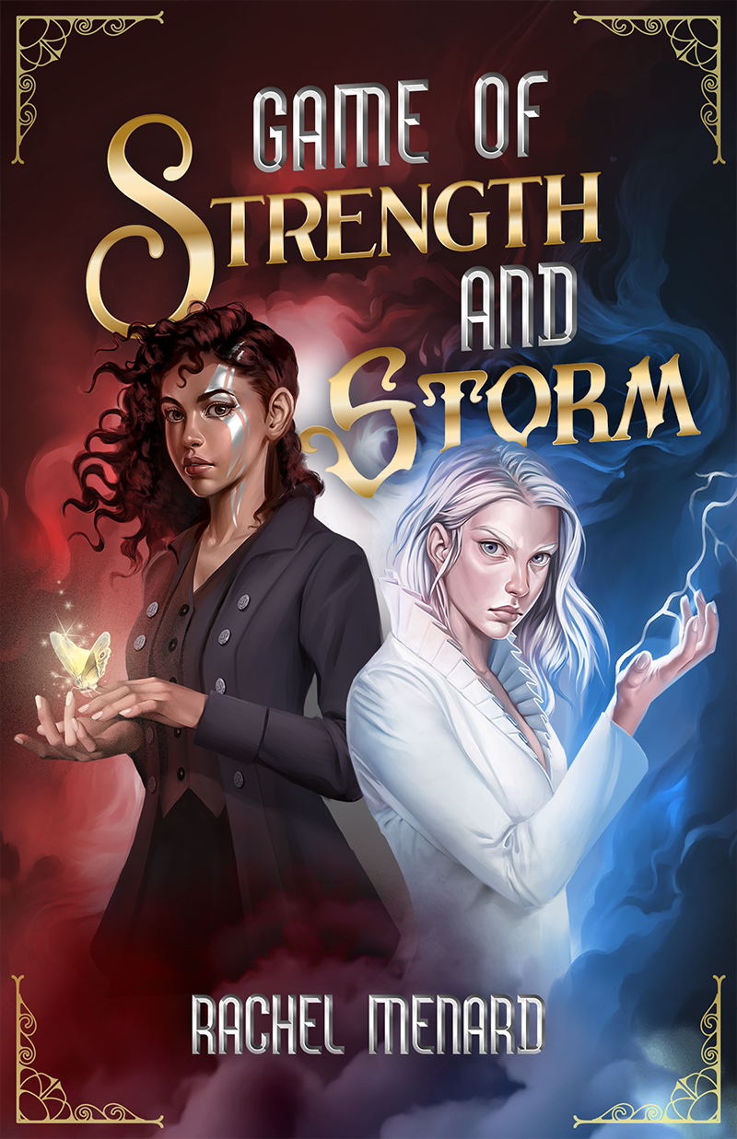
FOR IMMEDIATE RELEASE
ST. PAUL, MN, September 23, 2021– Flux, an imprint of North Star Editions, Inc. (NSE) is excited to announce the June 7, 2022 release of Game of Strength and Storm by Rachel Menard. In this gender-bent Hercules retelling, teenagers of Olympia Gen and Castor race to be the first to complete six nearly impossible challenges to obtain their greatest desire. Only one will win. The other walks away with nothing—if she walks away at all.
More about Game of Strength and Storm:
Victory is the only option.
Once a year, the Olympian Empresses grant the wishes of ten people selected by a lottery—for a price. Seventeen-year-old Gen, a former circus performer, wants the freedom of her father, who was sentenced to life in prison for murders she knows he didn’t commit. Castor plans to carry the island Arcadia into the future in place of her brother, Pollux, but only after the Empresses force a change in her island’s archaic laws that requires a male heir.
To get what they want, Gen and Castor must race to complete the better half of ten nearly impossible labors. They have to catch the fastest ship in the sea, slay the immortal Hydra, defeat a gangster called the Boar, and capture the flesh-eating Mares, among other deadly tasks.
Gen has her magic, her ability to speak to animals, her inhuman strength—and the help of Pollux, who’s been secretly pining for her for years. But Castor has her own gifts: the power of the storms, along with endless coin. Only one can win. The other walks away with nothing—if she walks away at all.
Game of Strength and Storm by Rachel Menard
Ages 14-18 / ISBN 978-1-63583-076-7 / $14.99 paperback original / 400 pages / Publication date: June 7, 2022

About the author
Rachel Menard was born in New Jersey, raised in Arizona, and then relocated to Rhode Island. Throughout her life she has been a barista, college radio DJ, singer in an alt-country band, marketer, designer, and finally, a writer. Her short fiction has been featured on Cast of Wonders and her editorial work has been seen in Writer’s Digest. Game of Strength and Storm is her debut novel.
For more information contact: Emily Temple, publicity@northstareditions.com, 651-424-4626

